Appendix D

MULTISIM TESTING

i/ direction 1 : Voltage is +71.979 VDC

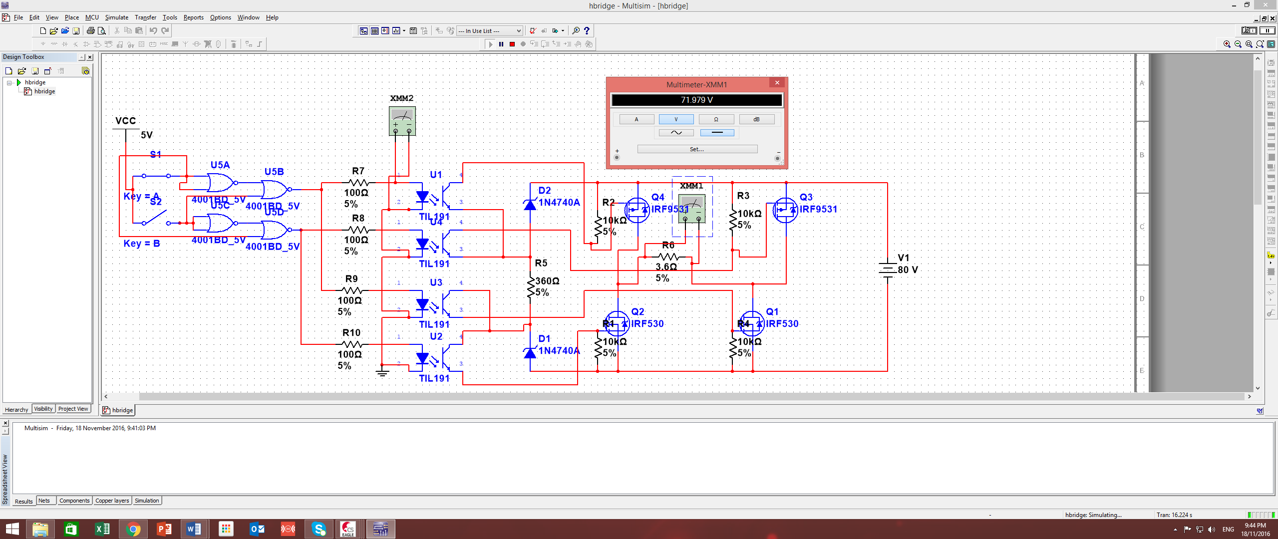

ii/ direction 2 : Voltage is -71.976 VDC

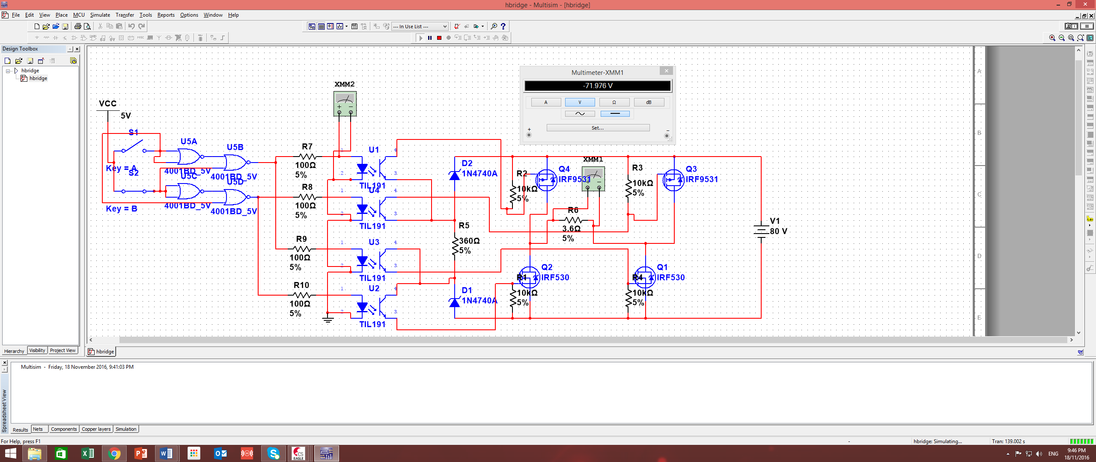

iii both switches on : about 16pV due to leakage

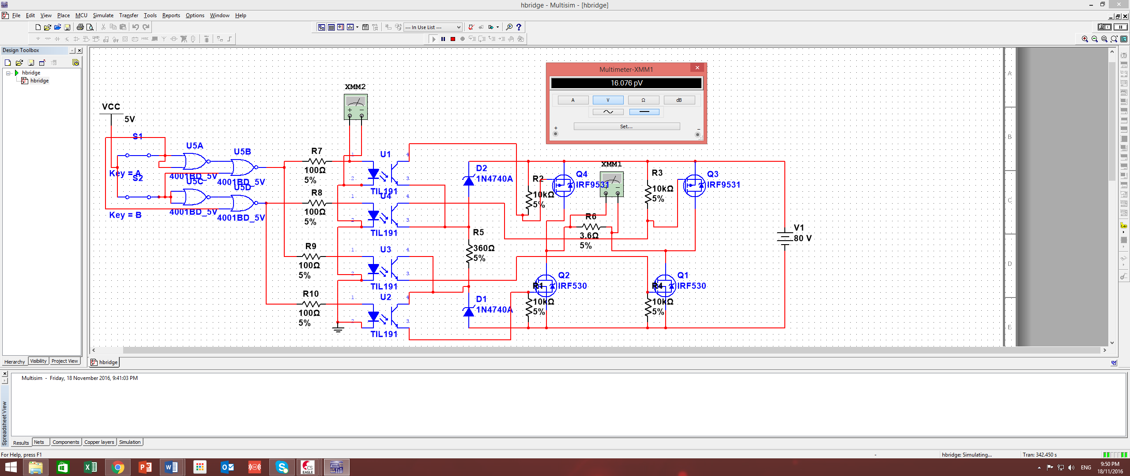

iv/ both switches off , voltage is about 16pV due to leakage

